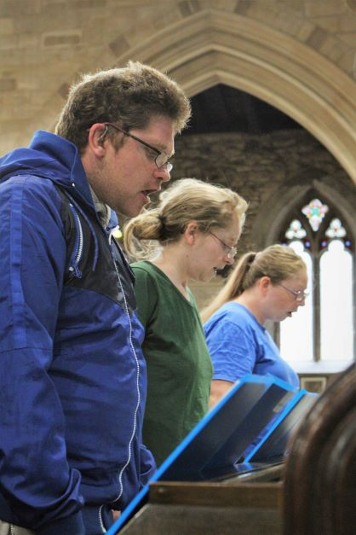

Trustee

Information Pack
www.soundcafe.org.uk

July 2023

SoundCafe is a community of acceptance, providing daytime activities
that give purpose and encourage self-expression for those who are homeless and isolated without a family or support network.

Introduction
SoundCafe Leicester (SCL) is a unique charity in its approach to supporting those who are homeless, vulnerable or isolated in Leicester City.
SCL provides day services across three days of the week and welcomes everyone regardless of race, religion, sexual orientation, gender or ability. Through our services we provide hospitality, friendship, a sense of community and support.
Our service focus is on singing together with SoundCafe choir; health and well-being through sport with SoundCafe Foxes football team and our weekly creative café incorporating arts, crafts and creative writing.
Volunteers including Samaritans support SCL’s work. Since the launch of SCL in October 2014 the number of people, our guests, accessing our service has grown considerably.
Our Patrons are the Bishop of Leicester, the Rt Rev Martyn Snow and Mrs. Janet Arthur (MBE).

The trustees of SCL include those with experience of working in the corporate setting as well as with rough sleepers, long term homeless, socially isolated people, those with drug or mental health issues and those who are destitute. This experience has shown us that we need to provide creative solutions to meet the diverse needs of those who are or were once homeless. We offer a choice of activities across the week to help those marginalised integrate back into society and provide a focus to their week.

Homelessness and the effects of it cannot be solved by a short term stay in a hostel or by one organisation. The pandemic has shown the need for adaptability of delivery model and finding creative solutions when faced with unprecedented challenges.

Key priorities for SCL are:

- Fully supporting our new delivery model as our future offering
- financial sustainability through both regular individual and corporate giving.
- ensuring our guests continue to have their voice heard through artistic expression
- extending our focus on health and well-being beyond our weekly football workshops.
- raising the profile and awareness of SCL service and opportunities

Alan Fletcher, Chair of Trustees
t: 07780 607063
e: alanfletcher@soundcafe.org.uk
w: soundcafe.org.uk
Our Trustees
SoundCafe Leicester Board of Trustees is looking to recruit new members with a passion for supporting vulnerable and isolated adults on the margins of society. Our Trustees bring a wealth of different experiences to the Board and make SoundCafe the charity that it is today.

The Trustee Board meets quarterly including the Annual General Meeting held in October. In addition, Trustees undertake two sessions training a year with a supporting strategy away afternoon/time. Trustee Meetings are currently held on a Wednesday evening 19.00 – 20.30 hours in Leicester.

The Board of Trustees oversee the strategic direction of SCL and its governing framework, with day-to-day operational management responsibility delegated to the Director. Delivery of SoundCafe sessions is supported by the Director, Service Co-ordinator and an Activity Co-ordinator supported by our team of volunteers.

As SoundCafe is developing we have identified the need to strengthen the Trustee Board including those with skills in human resources, legal and corporate, information technology, board secretariat, fundraising and medical or nursing expertise with a particular focus on mental health.

SoundCafe Leicester
Trustee Role Description

Responsible to: Chair of Trustees
Job Purpose: Developing and supporting the work of SoundCafe Leicester, with a specific remit to ensure:
- that the charity is carrying out its’ purposes for the public benefit
- compliance with its governing document and the law
- they act in the charity’s best interests
- management of the charity’s resources responsibly
- they act with reasonable care and skill
- the charity is accountable
Key Responsibilities
- Strategy & development, specifically:
  - advice, support and direction on the vision and mission of SCL and the necessary strategy, policies and procedures to ensure the future delivery and sustainability of the charity.
  - Review, scrutinise and challenge the vision and mission of SCL with specific regard to alignment to the charity’s written constitution.
  - working with the Director support the development of a Business Plan for SCL that addresses the future five-year vision.
- Take a lead role for a defined area of governance e.g., safeguarding or data protection in accordance with the key skill set required.
- Ensure that SCL:
  - complies with its governing documents and any other relevant legislation or regulations
  - utilises its resources appropriately in delivering its objectives
  - is effectively and efficiently administered
  - abides by all SCL’s policies and procedures
  - is properly insured against all reasonable liabilities
- Contribute actively to the board of trustees' role in giving firm strategic direction to the organisation, setting overall policy, defining goals, setting targets and evaluating performance against agreed targets
- Represent SCL at events and meetings as appropriate
- In addition to the recognised statutory requirements, use any specific knowledge or experience to help the board of trustees reach sound decisions. This will involve scrutinizing board papers, leading discussions, focusing on key issues, and providing advice and guidance requested by the board on new initiatives, or other issues relevant to the area of, the organisation's work in which the trustee has special expertise.
- Support the Director in the submission of bids for funding, providing expert advice and submission of documentary evidence as required.
- Build on external working partnerships that align with the future development of SCL
- Building bridges with other charitable providers of service.
- Work in accordance with the policies and procedures adopted by SCL.
- Maintain confidentiality of all information received.
Commitment
It is expected that Trustees will attend 4 routine Trustee meetings per year, the Annual General Meeting; and where possible attend an SCL session a minimum of once every ‘half term’. Where possible Trustees will be invited to attend and provide active support at fundraising events in support of SCL.
All Trustees, employees and volunteers are subject to the requirements of the Data Protection Act and must maintain strict confidentiality in respect of staff, guests and volunteer information.

Trustee Person Specification
 | Essential Criteria | Desirable Crieria
Values | - Integrity  - Commitment  - Openness  - Diplomacy  - Understanding  - Tact  - Inclusiveness  - Objectivity
Knowledge/Experience | Our Trustees over a range of skills within one or more area:  - Welfare/Pastoral/Homeless sector  - Finance  - Business Management  - Human resources  - Fundraising  - Communications/PR/Media/ Marketing  - Legal  - Safeguarding | Each trustee should have at least some of these  - Wide experience of organisations  - Great networks and a willingness to develop and use them.  - Experience at Board (or equivalent) level as a non-executive director or trustee  - An ability to understand financial information and sound business/commercial skills  - Experience of managing/governing significant organisational change and growth
Qualities/  Attributes | - commitment to the aims and objectives of SoundCafe Leicester  - ability to think strategically and creatively  - ambassador for SoundCafe | Willingness to:  - act as a member of SCL’s working parties/ sub-committees  - give time outside board meetings to action Board decisions in a timely manner  - represent SCL externally at meetings/events
Eligibility Criteria | You must be at least 16 years old to be a trustee of a charitable company or a charitable incorporated organisation (CIO), unless the charity’s governing document says you must be older. You must be at least 18 to be a trustee of any other type of charity.  You must not act as a trustee if you are disqualified under the Charities Act, unless your disqualification has been waived by the Commission. Reasons for disqualification include if you:  - are disqualified as a company director  - have an unspent conviction for an offence involving dishonesty or deception (such as fraud)  - are an undischarged bankrupt or have a current composition or arrangement including an individual voluntary arrangement (IVA) with your creditors  - have been removed as a trustee of any charity by the Commission (or the court) because of misconduct or mismanagement  - are on the sex offenders’ register  You will be required to make a written declaration to say you are not disqualified on any of these grounds.

